Title of the Manuscript: Concise, Informative, and Specific to the Main Topic of the Study (Bold, 14 pt, Title Case)
Title: Bold, 14 pt, Title Case. Maximum 20 words. No abbreviations or chemical formulas. The title must clearly indicate the main topic, material studied, and the key finding or objective.

First Author¹, Second Author², Third Author^{3,*}
¹ Department, University, Country
² Department, University, Country
³ Department, University, Country
*Corresponding Author: corresponding.author@email.com
Authors: Bold, 10 pt. Superscript numbers link authors to affiliations. Corresponding author marked with asterisk (*). Affiliation format: Department, Institution, Country in italic.

Abstract
Write your abstract here in a single paragraph of 150 to 200 words. The abstract must be written in the past tense and must include: (1) background and motivation; (2) research objectives; (3) methods employed; (4) main results; and (5) key conclusions. Do not include citations, abbreviations, equations, or references to figures and tables. A well-written abstract is the most important part of your submission as it determines whether readers proceed to the full paper.

Keywords: first keyword; second keyword; third keyword; fourth keyword; fifth keyword
Keywords: 4 to 6 terms, separated by semicolons. Do not repeat words already in the title. Choose terms that indexing services (e.g., Scopus, Google Scholar) would use to find your paper.

1. Introduction
The introduction must cover: (1) background of the field; (2) critical review of relevant literature with citations [1], [2]; (3) identified research gap or problem; (4) clear statement of objectives. The last paragraph must explicitly state what this paper aims to achieve. Length: 400 to 600 words. All citation numbers must be Bold, e.g., [1], [2].

Advanced materials play an increasingly important role in modern engineering systems, particularly in applications demanding high mechanical performance, thermal stability, and functional adaptability [1]. Recent developments in nanomaterials and smart material systems have opened significant possibilities for structural and functional engineering applications [2, 3]. However, the relationship between microstructural features and macroscopic behavior in composite systems remains insufficiently understood [4]. Therefore, this study aims to [clearly state the specific objective here].
Citation guide: Single [1], multiple [1], [2], range [1]–[3]. Always Bold. Citations must appear BEFORE the period at end of sentence. Example of wrong placement: "...as reported. [1]" — Example of correct: "...as reported [1]."

2. Materials and Methods
Describe materials, instruments, procedures, and analysis methods in sufficient detail for full reproducibility. Use sub-sections (2.1, 2.2) when multiple distinct methods are involved. Specify instrument brands, models, and settings. For statistical analysis, state software and significance level. Previously published standard methods must be cited, not described in full.

2.1 Materials
Describe the materials used, including source, grade/purity, and any pre-treatment. Example: Aluminum alloy (AA6061-T6, 99.5% purity, Sigma-Aldrich, Germany) was used as the matrix material. All samples were cleaned ultrasonically in acetone for 10 minutes at room temperature before processing.

2.2 Experimental Procedure
Describe the experimental steps in chronological order. Include key parameters such as temperature, pressure, duration, and equipment specifications. Where mathematical relationships are used, number each equation consecutively as shown below.
σ = F / A | (1)
where σ = tensile stress (MPa); F = applied force (N); A = original cross-sectional area (mm²).
Equations: Number consecutively with parentheses at right margin — (1), (2), (3). Define ALL variables immediately below the equation. Reference in text as "Equation (1)" or "Eq. (1)". Use Microsoft Word Equation Editor — never insert equations as images.

3. Results and Discussion
Present and interpret results supported by tables and figures. Every table and figure MUST be cited in the text in Bold (Table 1, Figure 1) before it appears. Citation numbers [1], [2] must also be Bold. Compare findings with literature. Use sub-sections when multiple aspects are discussed. Do not repeat data already shown — interpret it instead.

3.1 [First Aspect of Results]
The mechanical properties of the fabricated composites are summarized in Table 1. As shown in Figure 1, the tensile strength increased significantly with increasing reinforcement content. This trend is consistent with previous studies by Smith et al. [5] and Kumar [6], who reported similar improvements in aluminum-based composite systems. The enhancement may be attributed to the load transfer mechanism at the matrix-reinforcement interface, as described by Equation (1).
This paragraph demonstrates correct citation practice: Table 1 and Figure 1 are Bold, citation numbers [5] and [6] are Bold. Always cite before the figure/table appears. Reference Equation (1) when relevant.

Table 1. Mechanical properties of fabricated composite samples at different reinforcement contents (mean ± SD, n = 5)
Reinforcement (vol.%) | Tensile Strength (MPa) | Hardness (HV) | Elongation (%)
0 | 185.3 ± 4.2 | 72.4 ± 1.8 | 12.6 ± 0.9
5 | 214.7 ± 5.1 | 88.6 ± 2.3 | 9.8 ± 1.2
10 | 241.2 ± 6.8 | 99.1 ± 3.0 | 7.2 ± 1.5
15 | 228.5 ± 7.4 | 105.3 ± 3.8 | 5.9 ± 1.1
Table format: Title ABOVE the table, bold table number. Header row: dark background, white bold text. Alternate row shading. Include standard deviation (± SD) where applicable. Table caption must be self-explanatory without reading the text.
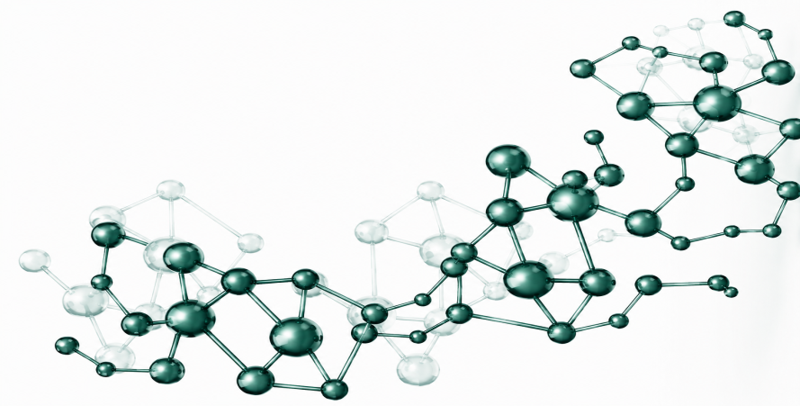
Figure 1. A complete, self-explanatory caption must be written here. Describe what is shown including key parameters and conditions. For multi-panel figures, label each panel as (a), (b), (c) and describe each in the caption. Example: SEM micrographs of composite samples at (a) 0%, (b) 5%, (c) 10%, and (d) 15% reinforcement content, showing particle distribution at 500× magnification.
Figures: Caption placed BELOW the figure. Bold figure number. All figures must be cited in text in Bold (Figure 1, Figure 2) BEFORE they appear. Never place a figure before its first citation. For multi-panel figures, label panels (a), (b), etc. and describe each in the caption.

3.2 [Second Aspect of Results]
The hardness results presented in Table 1 show a consistent increase up to 10 vol.% reinforcement, beyond which a slight decrease was observed. This behavior has been reported in similar studies [7, 8] and is likely caused by particle agglomeration at higher reinforcement contents, which creates stress concentration sites and reduces load transfer efficiency. Replace this text with your actual findings and discussion.

4. Conclusion
Directly answer the research objectives from the introduction. Summarize significant findings, state their scientific or practical implications, and suggest future research directions if appropriate. Do not repeat the abstract or simply list results. Length: 150 to 250 words. Can be written as a paragraph or numbered points.

This study investigated [topic] with the objective of [state objective]. The experimental results demonstrated that [summarize the most significant finding and its implication]. Furthermore, [summarize another major finding and its significance in relation to the first finding]. Based on these findings, [state the overall conclusion, practical implication, or contribution of the study]. Future research is recommended to [suggest direction for further investigation or improvement].

Authors' Contributions
List contributions using initials. Categories: Conceptualization, Methodology, Data Curation, Formal Analysis, Investigation, Validation, Visualization, Writing (Original Draft), Writing (Review and Editing), Supervision, Project Administration, Funding Acquisition.

FA: Conceptualization, Methodology, Writing (Original Draft). SA: Data Curation, Formal Analysis, Visualization. TA: Supervision, Writing (Review and Editing), Project Administration. All authors have read and approved the final manuscript.

Funding Statement
State the funding source, organization name, and grant number. If no funding received, use the standard statement below.

This research was funded by [Name of Funding Organization], grant number [XXX-XXXX]. —OR— This research received no specific grant from any funding agency in the public, commercial, or not-for-profit sectors.

Acknowledgements
Acknowledge support that does not qualify for authorship (technical assistance, equipment access, language editing). Do not include funding here.

The authors would like to thank [name/institution] for providing [specific support]. The authors also acknowledge [name] for technical assistance with [specific task].

Competing Interest
Disclose any potential conflicts. If none, use the standard statement.

The authors declare that they have no known competing financial interests or personal relationships that could have influenced the work reported in this paper.

AI Statement
Select the appropriate statement. Delete the one that does not apply.

Statement A — No AI tools used: This article is the original work of the authors without the use of AI tools for writing, creating, or editing sentences, tables, or figures in this manuscript.
Statement B — AI tools used: During the preparation of this manuscript, the authors used [Name of AI Tool] for [state specific purpose, e.g., grammar and language editing only]. The authors have reviewed, verified, and take full responsibility for the entire content of this manuscript.

References
Reference Requirements
Format: IEEE — numbered [1], [2], [3] in order of appearance. Minimum: 20 references. Recency: At least 80% from 2022 onwards. Sources: International journals and conference proceedings preferred.
In-text: Always Bold. Single: [1]. Multiple: [1], [2]. Range: [1]–[3]. Tool: Use Mendeley or Zotero with IEEE style. Include DOI whenever available.

Journal Article:
[1] J. Smith and A. Brown, "Advanced materials characterization using nano-indentation techniques," Journal of Materials Science and Engineering, vol. 10, no. 2, pp. 12–18, 2024. doi: 10.xxxx/xxxxx.
Conference Paper:
[2] S. Lee, R. Tanaka, and M. Chen, "Nanomaterials in smart engineering applications," in Proc. Int. Conf. on Advanced Materials and Technology, Singapore, 2023, pp. 100–110. doi: 10.xxxx/xxxxx.
Book:
[3] A. Kumar, Smart Materials and Engineering Technology, 2nd ed. New York: Springer, 2023.
Website / Online Source:
[4] A. B. Author. "Title of the webpage." Website Name. Accessed: Jan. 10, 2024. [Online]. Available: https://www.example.com
Add your actual references [5] through [12] or more here. Ensure every in-text citation has a matching entry and vice versa. List in order of first appearance. Include DOI for all journal articles and conference papers where available. Delete all sample references above and replace with your own.

